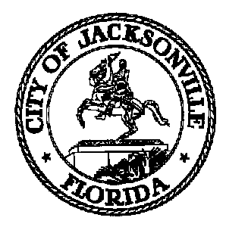
Taxation, Revenue and Utilization of
Expenditures (TRUE) Commission

Daniel Henry, Chair TRUE Commission
c/o Jeff Clements
Suite 425, City Hall
117 W. Duval Street
Jacksonville FL 32202
904-255-5137

TO: TRUE Commissioners

FR: Daniel Henry, Chair

RE: 2021 TRUE Commission Standing Meeting Notice

Notice is hereby given that the TRUE Commission will hold the remainder of its 2021 monthly meetings (typically, but not always, on the first Thursday of each month) at 4:00 p.m. as follows:

August 5, 2021
September 2, 2021
October 7, 2021
November 4, 2021
December 2, 2021

The committee will normally meet in the Don Davis Room, 1st Floor, City Hall at St. James, located at 117 W. Duval Street, Jacksonville FL. Alternate dates, locations or times may be posted as necessary due to changing conditions at a later date.

All interested parties are invited to attend.

For further information contact Jeff Clements, Chief, City Council Research Division, at 904-255-5137 or jeffc@coj.net.

c.c. Cityc@coj.net
City Council media notice box
File copy

Jeff Clements, Council Research Division Posted 7.27.21 11:30 a.m.

